System Design
Hospital MAR Fleet Management System
https://www.figma.com/design/wP5LvFIKbb7SGEeq8SyPIe/system-design?node-id=0-1&t=C99i5IF1sFV2Hcuw-1
Figma link containing all diagram and tables.
1.Requirements
1.1 Functional Requirement
- Develop the full operator-facing software layer for a hospital autonomous mobile robot (AMR) delivery system.
- The system consists of three interfaces: a nurse- facing mobile app, an on-robot touchscreen interface, and a web-based Fleet Management System (FMS) dashboard.
- All three interfaces must communicate over the hospital Wi-Fi network and be accessible from anywhere within the hospital without requiring a fixed workstation.
- FastAPI backend with JWT authentication, role-based access, mission lifecycle management, full AMR-FMS message protocol over WebSocket, and immutable audit log.
1.2 Non-functional Requirement
The detailed documentation of functional and non-functional requirement is attached in the link below.
https://writer.zoho.in/writer/open/44fzxca4cc9056a3a45f0b456d530f716fddd
2. Actors, roles and use cases
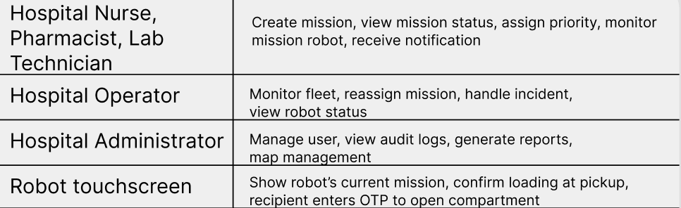
3.Clients and Interfaces
Who communicates with my system, and how do they communicate with it?
3.1 Clients
Nurse web app (mobile browser) -> Nurse, pharmacist, lab technician
FMS web dashboard -> Operator, administrator
Robot touchscreen -> Recipients at the robot
3.2 Interfaces
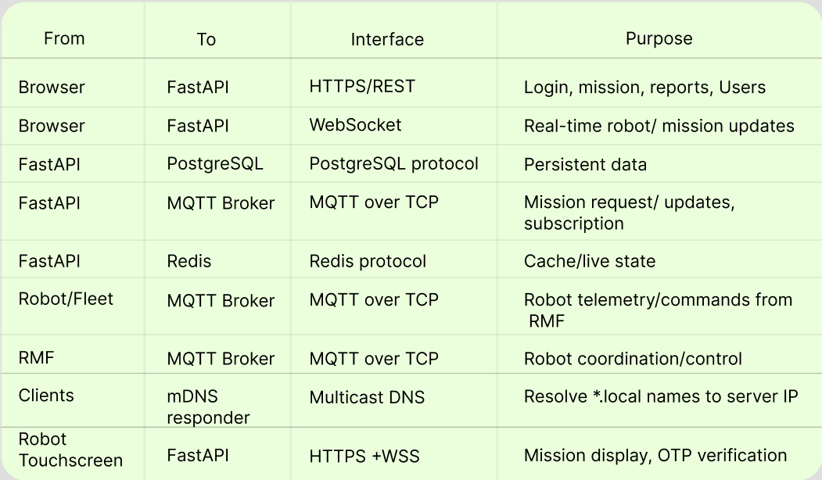
3.3 Interface flow
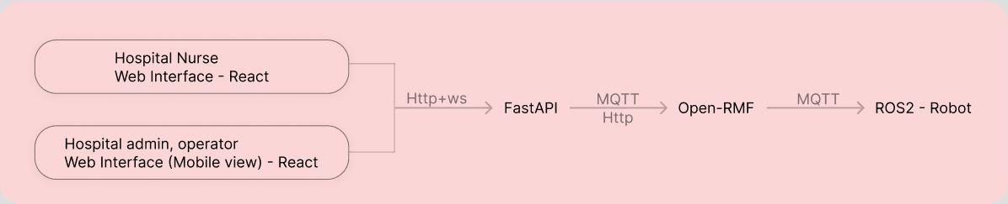

4.High-Level Architecture
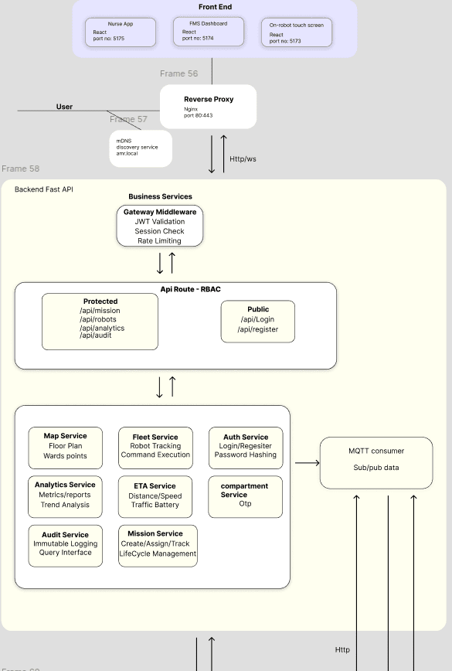
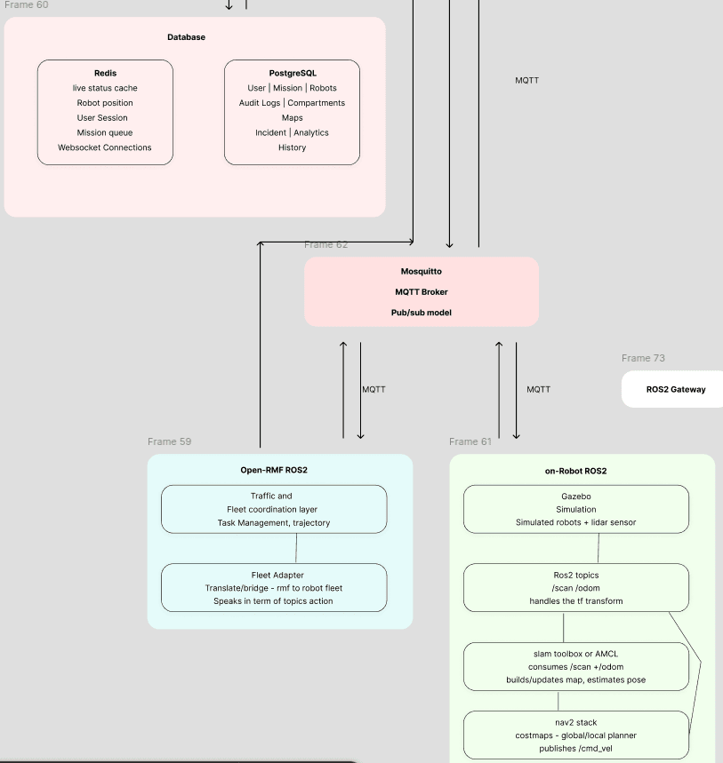
Extras-> Traffic Editor creates the facility representation graph which is the route used by every robot during mission. RMF uses it for fleet coordination during runtime. The fleet adapter connects RMF to th robots. MQTT transports messages. A translator funtion to translate MQTT to ROS2. Nav2 moves an individual robot. FastAPI runs hospital application. Redis provides current state. PostgreSQL stores durable histroy. Websocket delivers live information to React.
5. Component Design
5.1Edge: reverse proxy and local name resolution
Reverse proxy: an intermediary server in front of backend that intercepts all incoming client requests. Why it is used:
- Single entry point for the React applications and the backend APIs. Serve the React frontends and forwards Websocket upgrade requests to the FastAPI Websocket endpoint.
- TLS termination: decrypts HTTPS once at the edge; internal traffic stays on the private Docker network.
- Routing and path mapping: by host name and path (/api, /ws, static files).
- Security: hides internal topology; clients see only the proxy.
- Rate limiting and protection: throttles abuse before it reaches application logic.
- Load balancing: available if more than one FastAPI instance is introduced later.
Local DNS and service discovery.Lets hospital devices resolve the application host names to the server IP over the local network, with no public internet required. In production, use the hospital's internal DNS if it provides one.
mDNS is a name-resolution service contacted directly by client devices; it is not in the request path.
5.2 FastAPI backend
The FastAPI backend contains the system's application logic and provides the interface between the frontend, databases, and robot coordination infrastructure (Open-RMF).
5.2.1 GateWay Middleware->
- Process incoming HTTP requests.
- Validate authentication credentials.
- Apply authorisation checks and rate limits.
- Enforce appropriate request validation and security controls.
- Apply consistent error handling and request logging.
For protected operations, the backend validates the user's JWT and checks the permissions associated with their role.
5.2.2 API Routes and RBAC->
- Receive and validate client requests.
- Pass requests to the appropriate business service.
- Return structured responses.
- Enforce role-based access control (RBAC).
- Apply permissions to sensitive operations like create delivery mission, view audit records.
- Public routes: /api/login only. [CHANGED] /api/register is removed; users are created through the protected /api/users routes by an administrator. Protected: /api/missions, /api/robots, /api/analytics,/api/audit, /api/users and others.
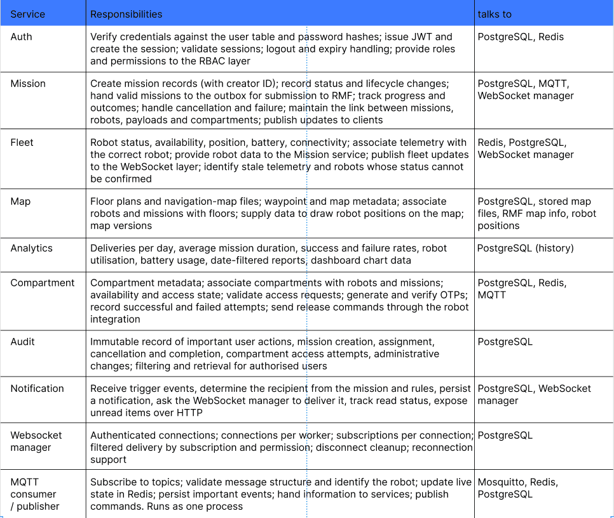

Notes:
- When the session expires, the backend should close the connection, and the frontend should redirect the user to log in again.
- OTPs should expire, have attempt limits, and be associated with the relevant delivery or access request. Compartment release must require appropriate backend authorisation.
5.3 Open-RMF layer
Open-RMF is the fleet, task and traffic coordination layer. It lets multiple robots share a facility and coordinates their movement and tasks. It decides which robot does a task, which route it takes through the shared facility, and prevents robots from interfering with one another.
- Receive relevant MQTT messages.
- Translate robot state and other supported messages into the appropriate RMF-facing representations.
- Forward commands or other relevant data through MQTT.
- Associate messages with the correct robot.
- Handle disconnections and reconnections.
- Report communication failures to the appropriate components.
Traffic: traffic schedules and planned trajectories; access to shared lanes and constrained spaces; conflict handling and replanning; doors and lifts; charging; coordination of all participating fleets.
Task management: accepts supported task requests, allocates and tracks them, coordinates with fleet capabilities and availability, supports interruption and failure handling. Before assigning, it considers battery, robot position, facility graph, traffic and task requirements, and can insert a recharge task when the charge is low.
Edge case, a person in front of a robot: RMF does not receive the robot's LiDAR or costmap. The robot's local Nav2 stack handles it. RMF handles the fleet-level problem.
Two integrations connect FastAPI and the robots to RMF. Neither is provided by installing Mosquitto or Open-RMF; both must be implemented or configured.
Rmf task bridge : FastAPI <--->Mqtt<-->RMFtask API
Fleet Adapter: RMF<--> MQTT<--> Robot integration layer
Fleet adapter speaks the language of RMF and a robot fleet. Robot Gateway integration speaks the language of MQTT and an individual robot's ROS 2 system. A gateway integration layer is a software integration layer for a robot type, vendor or protocol; it is not necessarily one process per physical robot.
5.4 Robot and simulation layer
Gazebo Harmonic: simulates the hospital, robot models, movement and sensors including LiDAR; supports testing without real robots.
ROS 2 Jazzy: topics and transforms; odometry and /scan; connects localisation, planning and control.
Localisation: AMCL during operation; SLAM Toolbox for building or updating a map
Nav2: planner server (global path), controller (path following), global and local costmaps, obstacle reaction,navigation progress and failure reporting.
6.MQTT
6.1 Why MQTT
One telemetry message must be consumed by RMF, the backend and logging. With HTTP every producer would send to every consumer. The broker is publish/subscribe: one message reaches many subscribers, robots do not need to know who consumes the data, topics organise the data, and MQTT provides selectable delivery guarantees and persistent sessions.
REST vs WebSocket vs MQTT. REST is for request/response operations (create mission, history, login, reports, update user). WebSocket is for continuous browser updates (robot moved, battery changed, mission status changed,robot disconnected). MQTT is for robot and RMF messaging between servers and robots.
6.2 Quality of service
QoS 0: acceptable for high-frequency updates where occasional loss is fine (telemetry).
QoS 1: delivery at least once; consumers must handle duplicates (state, events, commands, acks).
QoS 2: stronger delivery guarantee, but it does not guarantee the business operation happened exactly once. Not needed if command IDs and idempotent handling are used.
6.3 Message envelope and duplicates
{ "msg_id": "uuid", "command_id": "cmd-123", "robot_id": "robot_01",
"event_time": "2026-10-14T05:56:00Z", "payload": { ... } }
- Every command has a command_id, an acknowledgement and a timeout.
- Duplicate handling: if cmd-123 is delivered twice, the second is detected and not acted on. Mechanisms: unique constraint, the processed_commands table, Redis deduplication, event ID.
- A compartment-release command received twice must not repeat an unsafe action.
6.4 Consumer topology
If every FastAPI worker started its own MQTT consumer, each message would be processed once per worker (duplicate Redis writes, duplicate notifications). Run the consumer as one separate process (same code base, different container command). It writes to Redis and Postgres and publishes to Redis pub/sub; each FastAPI worker delivers to its own WebSocket clients from that channel. MQTT 5 shared subscriptions are an alternative if the broker and client library support them.
7. Authentication, session and security
7.1 Design decision
JWT in an HttpOnly cookie plus a server-side session record in Redis. A purely stateless JWT cannot be revoked before expiry. The requirement that a demoted administrator loses admin rights immediately needs server-side state, so the JWT carries a session ID and the gateway middleware checks it. PostgreSQL still stores accounts and roles; the application is not stateless as a whole.
Why an HttpOnly cookie: JavaScript cannot read it, so an XSS vulnerability cannot steal the token (with localStorage, malicious script could run localStorage.getItem('token')). The browser sends it automatically on HTTP requests and on the WebSocket handshake.
Why a separate /auth/session call: the user may reload, return after the JWT expired, or reopen the app, so the source of truth for 'who am I' is the validated session, not the login response. Why WebSocket authentication is separate: HTTP and WebSocket are separate connection events, and a WebSocket can disconnect alone and must re-authenticate on reconnect.

7.2 Login flow
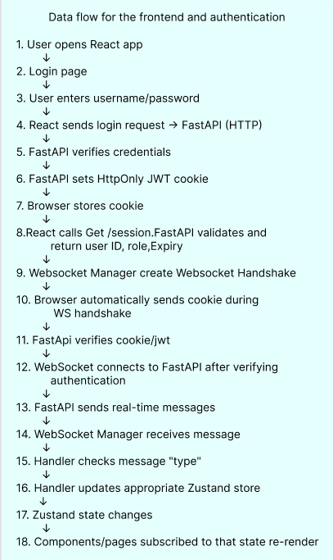
7.3 Session policy
- Access JWT 15 min, renewed by POST /auth/refresh while the session is active; idle timeout 30 min; absolute maximum 12 h (proposed). Without a refresh rule, a nurse would be logged out mid-shift.
- The frontend receives the expiry from the backend, keeps a timer (expiry time only, never the token) and shows 'session about to expire'. The backend enforces expiry regardless.
- On GET /auth/session returning 401 the backend clears the cookie (Set-Cookie: jwt=; Max-Age=0); React does not open the WebSocket and redirects to login.
7.4 WebSocket authentication and expiry
- The cookie must be valid for the WebSocket URL. WebSockets do not use the ordinary CORS preflight, so validate the Origin header explicitly during the handshake.
- Every subscription request is authorised against the role. A client must not be able to bypass authorisation just by requesting a topic name.
- The connection does not learn about JWT expiry by itself. The server keeps an expiry timer per connection and closes it with code 4401 at expiry; the frontend shows 'Session expired' and returns the user to login.
7.5 Role change and revocation
If an administrator changes user A's role (or demotes an administrator to operator), existing access must change at once: update the role, increment role_version, delete the user's sessions in Redis, publish session.revoked, and have the WebSocket manager close that user's connections with 4403. The user must log in again. Deactivating an account uses the same mechanism.
7.6 Security controls
Transport-> TLs at Nginx. Secure cookies require Https
CSRF -> SameSite=Strict cookies, same-origin. Origin check
Passwords-> bcrypt. login attempt limits and temporary lockout
Rate limiting-> Redis token bucket in application. Nginx limit_req at edge
OTP-> Hashed storage, expiry, attempt limit, generic failure messages, constant-time comparison, every attempt audited
Audit log-> Append-only: database role without UPDATE or DELETE
Logs -> Structured Json
Input Validation -> pydantic models
8. WebSocket protocol
One WebSocket per browser tab, authenticated by cookie. The server-side WebSocket manager tracks each user'scurrent subscriptions, so data is sent only to users who subscribed and are permitted to see it, instead of broadcasting everything to everyone.
When the user changes page the client unsubscribes from the previous topic and subscribes to the new one.Server-side topic authorisation is checked on every subscribe.
8.1 Message envelope
client -> server: { "type": "subscribe","topic": "robots" }
{ "type": "unsubscribe", "topic": "robots" }
{ "type": "subscribe","topic": "incident" }
8.2 Close codes
1000/1001 -> Normal close/ server restarting -> Reconnect
4401-> Session expired or invalid -> Do not reconnect, show "session expired", go to login
4403-> Role changed or forbidden -> Do not reconnect, login again
4429 -> Rate limited -> Reconnect after a delay
8.3 Reconnection
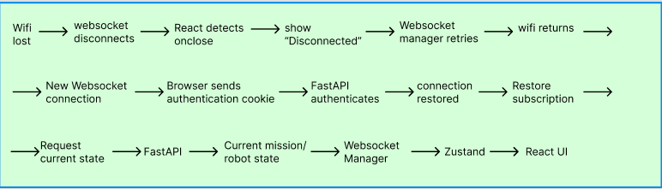
Note:
- Do not assume the old server-side connection or subscriptions still exist: the client re-sends its subscriptions.
- Unread notifications are fetched over HTTP (GET /api/notifications?unread=true).
9. Frontend architecture
Technology: React. HTTP/HTTPS for API requests, login and mission creation. WebSocket for real-time mission
updates, robot status and notifications.
9.1 Three levels of data
- Local component data: for example deliveries for the last 30 days on one page.
- Feature data: for example fleet: robotMap, robotCard, robotList.
- Shared application data: for example live robot state, needed by both the fleet and mission features.
9.2 Structure
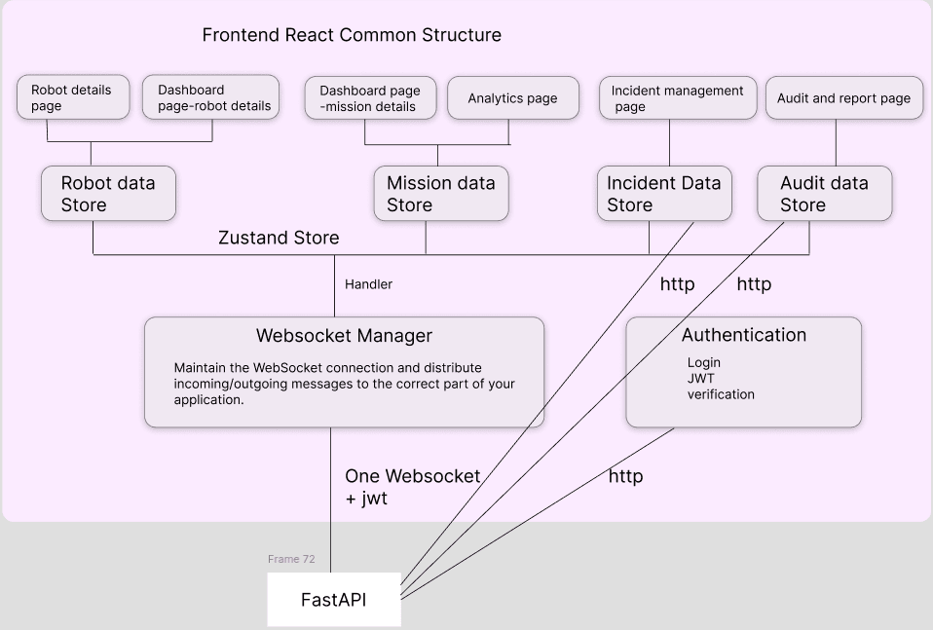
Incident and Audit data are loaded over HTTP (paged) and refreshed by WebSocket events. Authentication (login, session verification) uses HTTP.
Why a WebSocket manager: it maintains the single connection (with automatic reconnection) and distributes incoming and outgoing messages to the correct part of the application, so other pages never deal with WebSocket details. It solves: multiple connections, multiple message handlers, repeated reconnection code, every page having to understand the protocol, and hard maintenance. The message type field lets a handler route each message to the correct store. (This client-side manager is distinct from the server-side WebSocket manager in FastAPI.)
Why Zustand: ordinary React state belongs to one component. Zustand holds shared current state as an object that any page can read, so nobody has to find the pages and pass them the data.
Why Handler in websocket Manager -> it separates the message and routes it to the correct zustand store.

9.3 Robot touch screen
Build the touchscreen interface once and open it in a browser on every robot. One React page reads the robot ID from the URL (useParams()); only the ID changes. The backend returns that robot's data (GET /api/robots/robot-1).
In production, store the robot ID in local configuration on each robot, and authenticate with a device token because a URL parameter alone can be changed by anyone.
Connection-state display: every frontend shows 'connected / disconnected / session expired' and the freshness of robot data ('live' vs 'last seen 12:04').
10. Key flows
10.1 Initial page load
Browser asks for http(s)://nurse-app.local; mDNS resolves the name; Nginx serves index.html from the configured build directory; the browser reads it, discovers the JS and CSS files and requests them from Nginx; React executes in the browser and the login page appears. Nginx delivers files; it does not run React.
10.2 Nginx configuration example
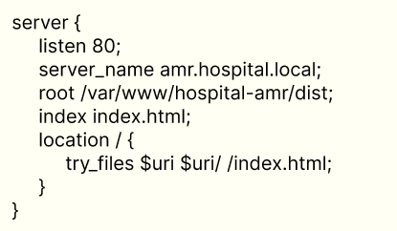
10.3 Login sequential diagram
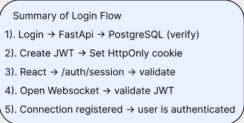
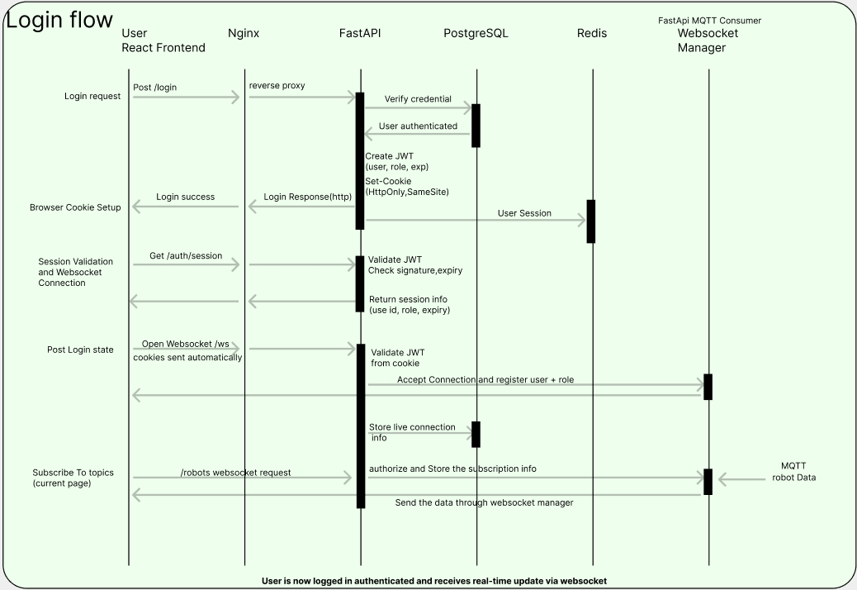
10.4 Mission creation, submission
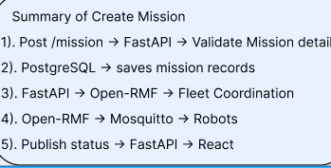

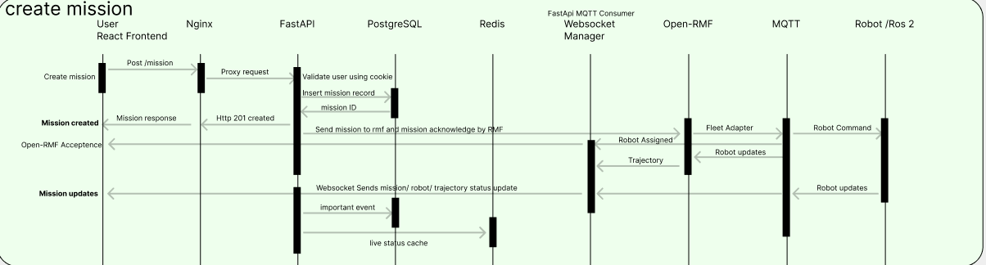
- Idempotency: the client sends an Idempotency-Key (UUID) with the request. A unique constraint on (created_by, idempotency_key) makes a retry return the original mission instead of creating a duplicate. This replaces the original rule that a user can create only one mission at a time, which is a business restriction, not idempotency, and would block Quick Book.can request another after receiving appropriate response for it.
- Store first: the mission is inserted in PostgreSQL (pending, not submitted) before anything is sent to RMF, with a unique application-level mission_id. Also helps in crashes.
- Acknowledgement: on the task response, submission_status becomes accepted or rejected and rmf_task_id is stored. If no response arrives in time, it becomes 'submission unknown' and is reconciled before any retry.
- FastAPI crashes before recording the acknowledgement: on restart, 'submitted' and 'unknown' rows are checked against RMF (matching the mission_id in the task) before resubmitting, so no duplicate task is created.
- FastAPI acts as the durable mission record and recovery coordinator, not a second robot execution queue.
10.5 Telemetry flow
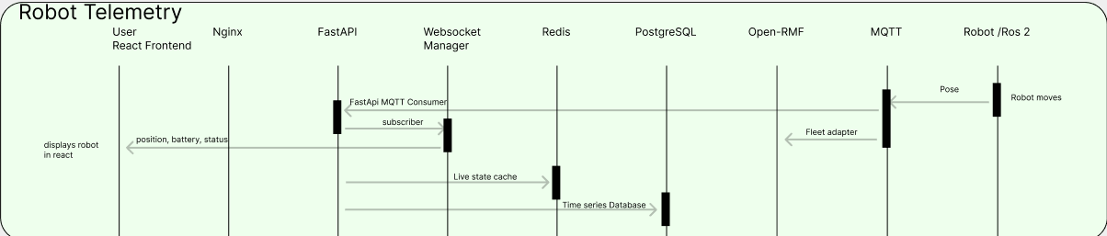
Note:
- Consumer validates structure, identifies the robot, updates Redis (state and presence).
- A batch writer stores downsampled rows in PostgreSQL; important events are written immediately.
- Incase of multiple FastAPI workers, Consumer publishes to Redis pub/sub; each FastAPI worker's WebSocket manager sends the update only to users subscribed to that robot or fleet topic
10.6 Delivery lifecycle and compartment handoff
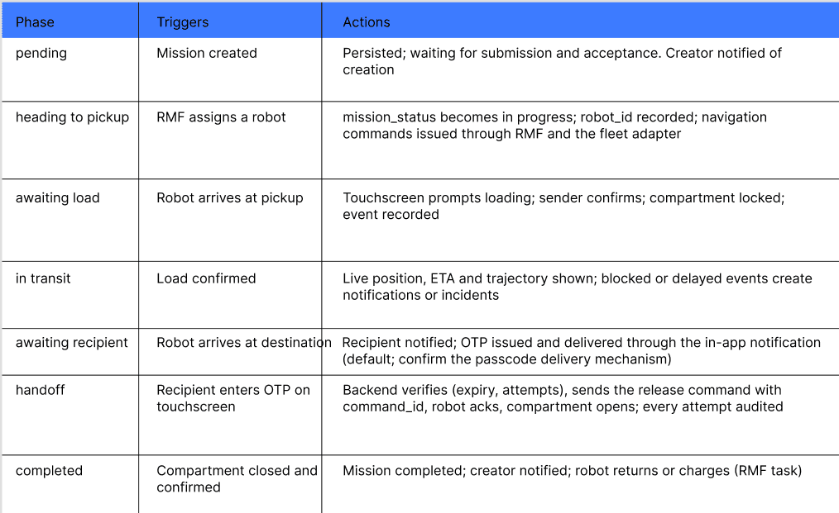
10.7 Notifying specific user
Nurse U101 creates mission M501. The mission record keeps the creator ID (and recipient ID). When the robot completes M501, the Notification service looks up the mission and determines that U101 is the recipient, creates a persistent notification row (recipient_id = U101), and asks the WebSocket manager to deliver it to U101's connections only . Read status is tracked. If U101 is offline, the unread notification is returned over HTTP on reconnect.

11.Reliability and failure handling
11.1 Failure matrix
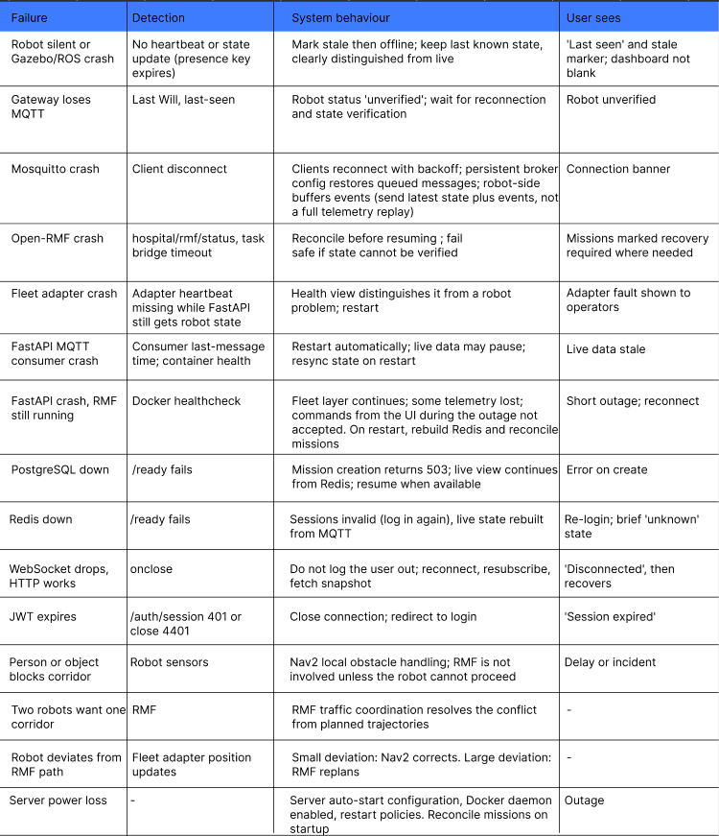

11.2 RMF failure and mission recovery
Saving the queue in Postgres survives a crash, but it does not say what happened to the robots during the crash. A robot may still be moving, may have stopped, or may have finished its delivery. Recovery therefore uses the actual execution state, not only the last saved status. Example: robot 1 is delivering medicine to ward A; robot 2 has a pending lab-sample pickup; RMF crashes. The two robots must be handled differently.
- RMF processes run under a service manager (systemd or Docker restart policy). A monitoring component checks that RMF services respond (periodic verification) and publishes hospital/rmf/status.
- Scenario A: RMF crashes but Nav2 keeps moving the robot. Consider traffic conflicts, doors, lifts and shared corridors. Scenario B: RMF crashes and the robot completes its task: reconcile with recovered data.
- When RMF recovers: check for a healthy reconnection, obtain each robot's actual state, then compare PostgreSQL, recovered RMF task state and actual robot state.
- The navigation graph is reloaded from the configuration artifact and the runtime RMF graph recreated; operation continues from there.
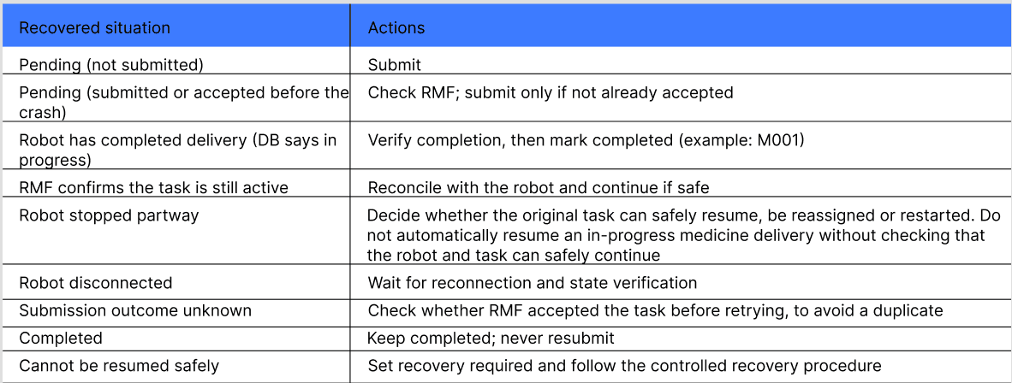
11.3 Robot connectivit and health model
Track each layer separately and combine them for display.
Robot status values: online, stale (3 missed heartbeats), offline (6 s without state), unverified (reconnected, state not yet confirmed). A dead-robot display shows the last known position with 'last seen'. If HTTP works but WebSocket does not, the user is not logged out.

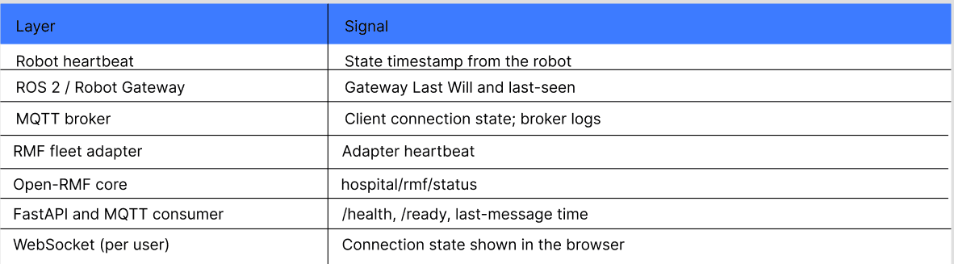
12 Robot, simulation and map layer
12.1 Map and facility artifacts
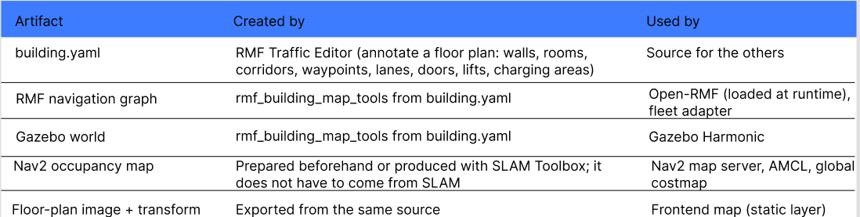
One source (building.yaml) generates multiple outputs, because Gazebo needs a world and models while RMF needs a graph and waypoints. Phase 1: use Traffic Editor. Phase 2: build a web map editor that generates equivalent RMF data. Store the generated nav graph with the simulation files; keep metadata in the maps table (map_id, name, floor, version, file path, created_at).
The RMF graph is the facility's navigation network of waypoints and lanes, the shared road network RMF plans on. A trajectory is one robot's planned trip through that network.
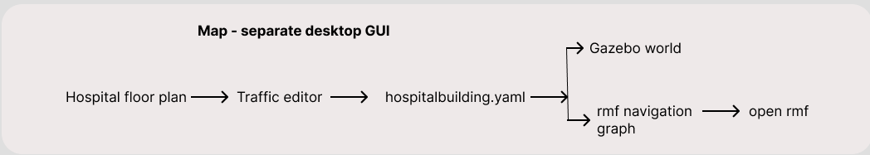
12.2 What the facility graph and configuration define
- Navigation graph: waypoints, lanes, floors, docking points, charging locations, pickup and drop-off locations, holding and pass-through points.
- Fleet and robot configuration: robot profile, footprint, vehicle and battery characteristics, fleet, starting locations.
- Task types: delivery, loop or patrol, cleaning, docking, charging.
12.3 Fleet adapter and RMF integration
- Use RMF's EasyFullControl adapter API: add robots, provide their state, and implement the navigate, stop and localise callbacks. RobotUpdateHandle supports position updates and replanning requests.
- Configure: navigation graph, fleet configuration, robot names, initial positions, vehicle characteristics, battery parameters, charger location, navigation callbacks, state updates, MQTT integration.
- Commanding strategy: the adapter can send the next goal immediately and the following goals as RMF requests them, or send the whole route at once. Prefer per-goal commands, so RMF keeps control of pacing and replanning.
- Deviation: small local deviation is handled by Nav2; significant departure from the RMF route triggers an RMF replan.
- Battery: RMF task planning accounts for battery and can insert a recharge task.
12.4 Coordinate frames
RMF's building map (pixel scale and level offsets), the Nav2 map (resolution and origin in map.yaml), the Gazebo world and the frontend floor image all use different frames. Generate the Nav2 map and the Gazebo world from the same building.yaml where possible, and store the transform (origin, scale, rotation) for each map version in the maps table. The frontend uses this transform to draw robot positions and RMF trajectories over the floor image. Without it, positions on the dashboard will be offset.
12.5 Localisation and NAV2
- AMCL estimates the robot's pose on an existing map from LiDAR, odometry and the map. Use it in normal operation.
- SLAM Toolbox builds or updates a map while estimating pose. Use it to create the initial navigation map. They are alternatives for different stages, not two components that always run together.
- TF chain: map -> odom -> base_link -> laser. AMCL estimates map -> odom; odometry supplies odom ->base_link.
- Navigation loop: planner computes a path, controller follows it, /cmd_vel drives Gazebo, simulated movement produces /scan and /odom, which update the costmaps and AMCL, then the next control cycle.
- Costmaps: the global costmap (static map plus configured sensor layers) feeds the global planner; the local costmap (nearby obstacles from LiDAR) feeds the controller. A sensor observation never permanently changes the static map.
- The RMF graph is the facility-level plan. The fleet adapter turns it into a Nav2 goal; Nav2's planner produces the local robot path; the controller drives the robot.
- RPP follows the path by steering toward a point a little ahead of the robot ('pure pursuit'), and regulates speed, for example slowing in turns, producing velocity commands. Alternatives: DWB (dynamic obstacle avoidance), MPPI (predictive), TEB and others; planners NavFn, Smac, Theta*. The choice depends on drivetrain, footprint, speed, turning limits, corridor width and obstacle behaviour.
12.6 Simulation notes
- The Nav2 map server publishes the static occupancy map on /map. Gazebo simulates LiDAR and publishes /scan and /odom through ROS 2.
- The pose reported to RMF and the dashboard should be the localised pose from the ROS 2 stack, not Gazebo ground truth, for realism.
- The frontend receives the static map, robot state and RMF trajectory separately and combines them visually. It never receives or renders the Gazebo world.
12.7 Changing the map
Do not change a waypoint underneath a robot that is using it. Use a controlled migration: stage the new map version, activate it when no active mission uses the affected lanes (or in a maintenance window), restart or reload RMF with the new graph, then mark the version active in the maps table.
12.8 Robot Gateway interface in ROS2 robot layer
- First find what the robot interface provides: robot state, navigation API (send goal, cancel goal), get pose, get battery.
- Define the MQTT interface. The gateway subscribes on the robot side, converts MQTT commands into ROS 2 commands, and listens to ROS 2 robot state for publishing.
- Commands are handled carefully with command IDs and acknowledgements.
- Mosquitto in production runs as a managed service or container, not a manually started process.
13.Deployment and operations
- Use the 'unless-stopped' restart policy: Docker restarts crashed containers unless they were stopped explicitly. Use depends_on with health conditions for startup order.
- Restart container unless we explicitly stopped it.
- Restart policies do not protect against everything: if the server loses power, enable automatic startup of the OS and the Docker daemon.
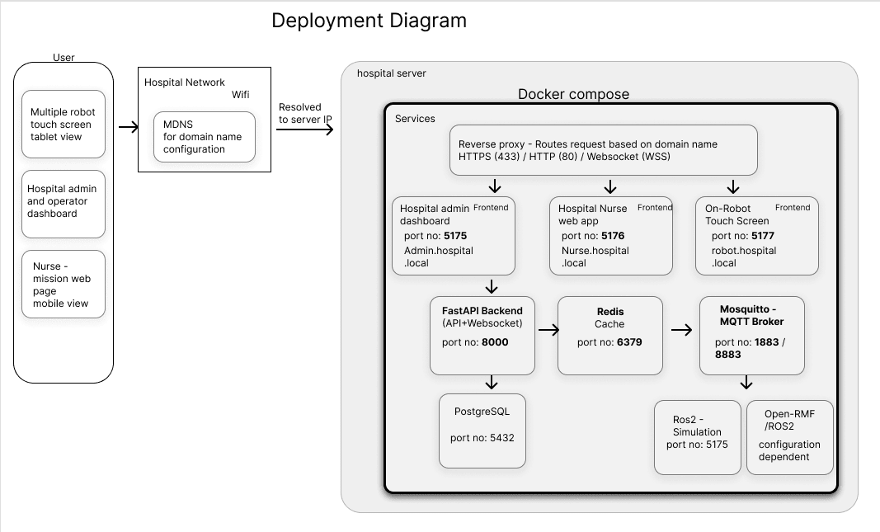
13.2 Networking cautions
- mDNS: intended for local-link discovery. Wi-Fi client isolation, VLANs and segmentation can stop devices from resolving or reaching the server.
14 Data design
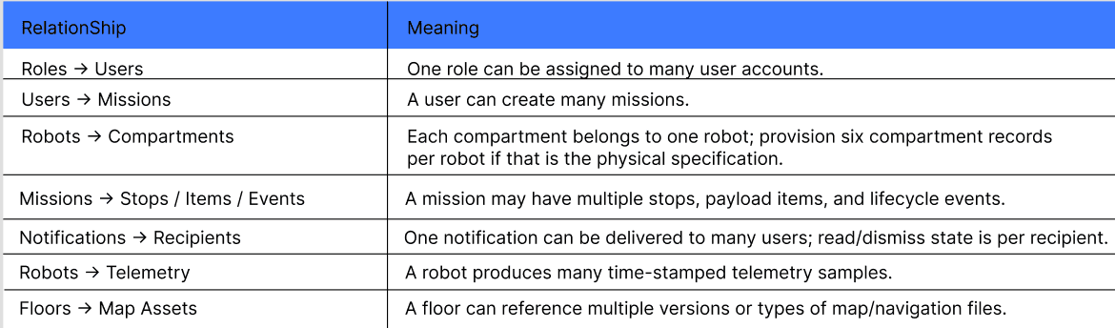

Telemetry storage-> TimescaleDB
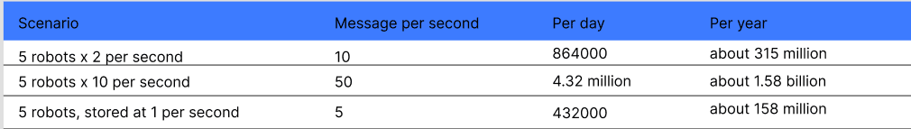
- Do not persist every message. Live state goes to Redis at full rate. History goes to Postgres downsampled (proposed 1 per second per robot) in batches.
- Columns: robot_id, event_time (robot timestamp), received_at, x, y, yaw, speed, battery, status, and optionally mission_id
- Partitioning: range-partition by event_time (for example monthly). A query with a time range scans only the matching partitions (partition pruning).
- Loss on crash: a batch held in FastAPI memory is lost if FastAPI crashes. This is acceptable for telemetry. Important events are written directly and are not batched.
Consistency model
- Consistent (CP): mission creation and assignment, compartment and OTP state, user and role changes.Postgres is the source of truth
- Available (AP): live telemetry. A slightly stale position is better than no position.
- Idempotency: mission creation by idempotency key; commands by command ID; events by event ID.

conceptual ER diagram
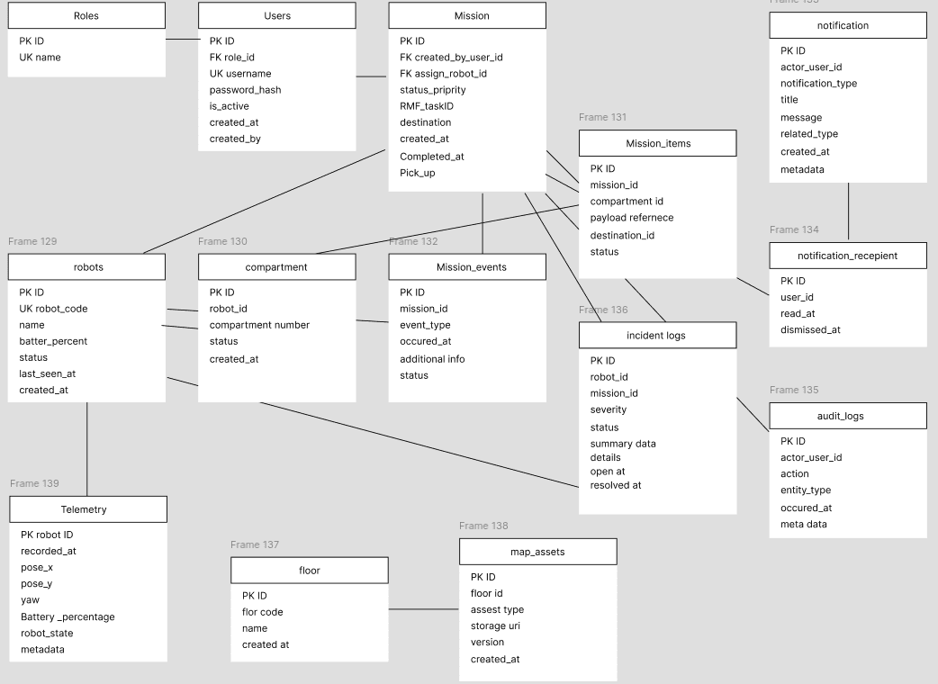

Future upgrades
- Send link in mail too user to set password or change password
- Robot manual open for compartment incase of malfunctions
- Block other users/admin from using manage mission if one admin is already accessing a specific robots manage mission
- Timeout if manage mission selected and make it available if the admin selected it is not managing the robot.
- Other nurse should be able to see their wards delivery and able to accept it in case of emergency
- Robot register page to introduce new robots
- Maintenance page and role for maintenance.
- Sending every week, monthly activity to all admin via mail
- Slam mapping option for robot to map and use it via map editor to create facility graph.
- Horizontal scaling (add multiple FastAPI servers)
- Dynamic reroute option for robots in the admin page

